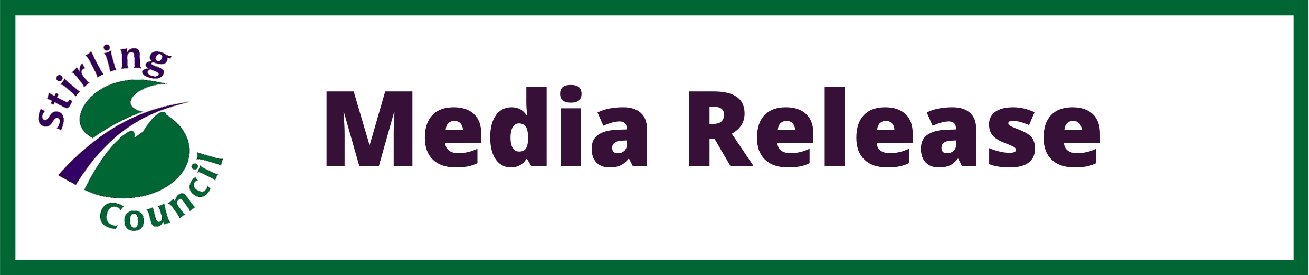

£150k community regeneration fund open for applications
Community groups and other third party organisations can now apply for grants from a £150,000 fund as part of Stirling Council’s Place Based Investment Programme (PBIP).
Applications must align with the objectives of the Scottish Government scheme which include:
- Investments are shaped by the needs and aspirations of the local communities.
- Support ambitions such as town centre revitalisation, community-led regeneration, community wealth building and *20-minute neighbourhoods.
- Accelerate ambitions for net zero, wellbeing and inclusive economic development and tackling inequality.
Both rural and urban locations across Stirling that meet certain conditions are eligible to apply for the investment.
Successful applications will be allocated a project liaison officer for support and advice, with the grant to be used in the current financial year (ending 31 March 2022).
The initiative was approved as part a £735,000 package of investments by the Council’s Finance and Economy Committee on Thursday (17 June) following the awarding of a central grant from the PBIP.

Convener of the Committee, Cllr Margaret Brisley said: “This is a fantastic opportunity for groups and organisations across Stirling to develop and lead on projects that will deliver positive change for their local community.

“Officers from our Economic Development and Communities Service will be there to offer support and guidance throughout the process so if you are interested, please get in touch.”

Vice Convener, Cllr Alison Laurie said: “No one knows their community better than the people who live and work there which is why we allocated a substantial part of the PBIP funding for third party organisations.

“I’m looking forward to seeing the projects that come forward from across Stirling to support our commitment to creating vibrant, inclusive and accessible communities.”
Expressions of interest must be submitted by Monday, 2 August.
Please email InvestinStirling@stirling.gov.uk to request further information or a call back the Council’s Economic Development and Communities Service.
For more information, please visit the dedicated webpage on the Invest Stirling website.

