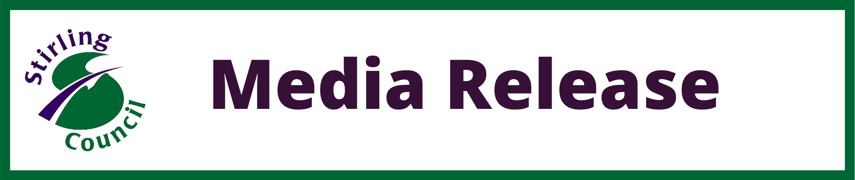

Joint Statement from Stirling Council and NHS Forth Valley

Targeted plans to limit the spread of Covid-19 in the Stirling villages of Fallin and Throsk have been put into immediate action.
An asymptomatic Mobile Testing Unit has been set up at the Community Centre while temporary remote learning measures have been put in place for all children living in the area who attend Stirling Council schools and nurseries.
Special measures have also been implemented to ensure dedicated access to testing for each of the targeted groups:
- Fallin Primary and Fallin Nursery will move to remote learning from 12-19 March (inclusive), with families offered exclusive access to the testing unit on Friday to Sunday (12-14 March), and the following Thursday to Saturday (18-20 March).
- Fallin-based children who attend other schools and nurseries across the Council area will also begin remote learning on Friday, 12 March to Wednesday, 17 March. Exclusive access to the Mobile Testing Unit will be provided for these pupils and their families from Monday, 15 March to Wednesday 17 March inclusive.
Stirling Council Leader, Cllr Scott Farmer said: “The safety of our communities and staff is our top priority and we have put these targeted measures in place in consultation with partners to prevent the virus from spreading further.
“The recent surge in positive cases in Fallin comes against a backdrop of consistently high levels of Covid-19 in that community and, with thanks to NHS Forth Valley, we have taken decisive action to tackle this developing situation.
“I would encourage all families we have contacted to get a test. Support is available if someone tests positive and they need to stay off work, so please take this opportunity to get tested and protect your family.”
The NHS Forth Valley Test and Protect team are working closely with Stirling Council and the decision to begin testing was taken after a careful risk assessment.
NHS Forth Valley Consultant in Public Health Dr Henry Prempeh said: “The new Coronavirus variant is highly infectious and I would urge the families contacted by schools to take up the opportunity of a test to protect both your family and loved ones, as well as the wider community.
“Although the number of Covid cases in hospital is decreasing, the virus is still very much out there, and we cannot afford to become complacent.
“I would also like to stress the importance of continuing to follow the national guidance to minimise the risk of transmission. This includes two metre physical distancing; the use of face masks in public and work places, washing your hands with soap regularly; and using hand gel where appropriate.”

