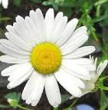

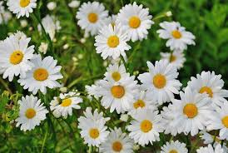

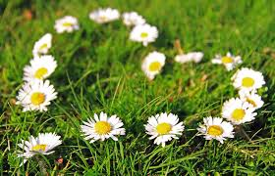

Wellbeing
on Friday, April 2
at 7.30pm
Approximately 30 minutes of readings on the above theme interspersed with music. Feel free to share a prayer/ poem/reading after the set programme.

Join Zoom Meeting
https://us02web.zoom.us/j/82382190176
Meeting ID: 823 8219 0176
Passcode: 060332

All welcome

Do not be content with showing friendship in words alone, let your heart burn with loving kindness for all who may cross your path... Let it be seen that you are filled with universal love.
- ‘Abdu’l-Bahá

