Report on river boat trip planned for Friday 24th May
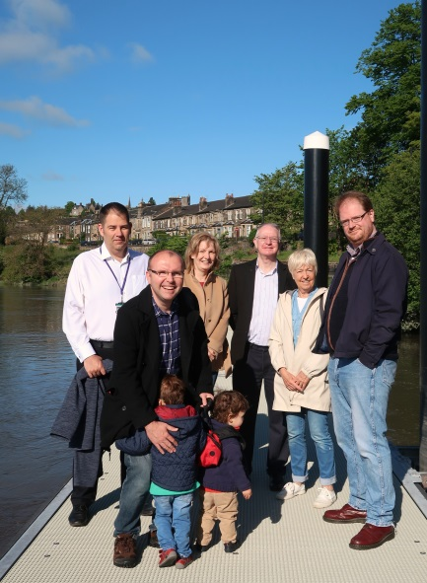
Anne Ferguson, Stirling Council, invited a member of the Community Council to go on a tour on the River Forth on Friday 24th May. The plan was to leave from the pontoon at 8.15 am, head down to the loop behind the PEAK and Cambuskenneth Abbey, and then head back up to the old bridge, before returning to the pontoon.
Unfortunately the boat had mechanical problems and got stuck on the way up so the trip had to be cancelled because of the tides. However I had a useful discussion with:
Brian Roberts, Senior Manager, Infrastructure, Stirling Council
Anne Ferguson, Stirling Council (who had brought a picnic!)
Clrs Jim Thomson, Susan McGill, Neil Benny, Danny Gibson (and his children)
- They are hoping to do another boat tour as soon as possible
- They are currently working with a local boat skipper to identify opportunities for running a boat service on the river and are keen to involve Riverside Community Council due to the pontoon’s location in Riverside
- Anyone can get access to the pontoon – but they first have to complete a form which Anne will send to us.
- They are going to put up a notice about this in the park
- Suggestions included trips focusing on local history, the river environment, wildlife ….
- It was suggested that a small group of Riversiders (3/4) could work with the Council to find out what locals would want
- They are keen for any suggestions/improvements we think would improve the use, accessibility and opportunities associated with the boat service
- They are planning to run pilot boat trips for a 3 month period later this year
Thanks to Sue Dumbleton for photo
Joan Murphy 26.5.19

