Riverside Bowling Club
Queenshaugh Drive
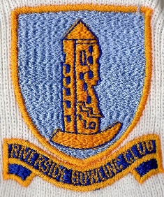
STIRLING
FK8 1XL
Club Secretary
John Millar
Email: johntmillar@aol.co.uk
Mobile number: 07709058642
RBC has Opened for Season 2021
If you’ve been unable to get down to the Bowling Club yet, we hope to see you soon. Opening Day was last Saturday, and even though it was wet over 30 people attended to see the Club Opening for the season. We were unable to play, but the Opening Day’s play has been postponed to this Saturday (Saturday 15th May) at 2pm, when a team representing the Past President will play a team representing the President for this season. We hope to see a good turnout on the day of which we will be able to have 30 playing members on the green. Club tops are encouraged to be worn for this Saturday.
Membership fees
If you’ve been unable to pay your subscription, contact Geoff Sutherland on mobile no. 07598 9763562, or pay online, a/c no. 00735005, sort code no. 80-91-29
Corvid 19 Regulations
This season’s regulations still apply from last season. Track and Trace is in operation, therefore all play on the green must be registered. If you want to practice, or want a bounce game, then you must notify either Tom Findlay jnr on mobile no. 07883 168638 or Ian Mackenzie on mobile no. 07825 913395 or Geoff Sutherland on mobile no. 07598 9463562, who will book you on a rink for play and a time. Organised mixed rink games don’t have to be booked as there is an assigned person registering people as they enter the clubhouse. Mats and jacks are situated at back of gate of the main gate entrance and you are asked to wash mats and jacks after play in disinfectant and water in boxes provided. Please wash your hands as you enter, sanitisation areas are vestibule of main entrance, main entrance to clubhouse and entrance to lounge.
100 Club
Entries for this valued club fund can still be made. As we have only just Opened the Green, we will have two draws in June, one in July, one in August and our last draw of the season in September. Entries are £10.00 and can be given to Geoff Sutherland, or pay online, a/c no. 06021075, sort code no. 80-91-29
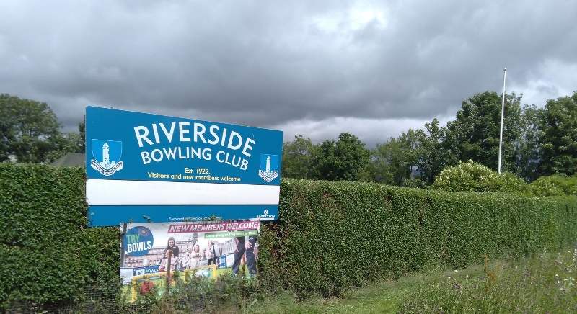
Friendly Fixtures
We will be entering Tier 2 of Covid19 regulations next Monday therefore Bowls Scotland will allow us to play friendlies from that date. George Grant (match secretary) will be notifying members of the games ahead, and fixture dates will be on the Noticeboard.
Internal Competitions
The Playing committee will meet next Monday and competitions will be advertised for season 2021.

Rink Games
Mixed rink games have now started and take place on Monday evenings from 7pm, Tuesday and Thursday afternoons from 2pm and Saturday afternoons from 2pm. Please support these games.
Coaching Nights
Coaching Nights will resume from Wednesday 19th May at 7pm. If you haven’t played for a long time or if you are a new member, come along on a Wednesday night and build your confidence on playing the sport of bowls. If you require further details, contact myself, per above contact details.
Friday Night in the Lounge
At last our Friday night’s in the Lounge will resume on Friday 21st May. The Lounge will welcome back all social and playing members. Come along and meet again and enjoy a game of pool!

I look forward to meeting you all during the season. We hope that in the next couple of months the coronavirus Tier structure will ease further for us all. I would ask all playing and social members to adhere to all Covid19 regulations issued by Bowls Scotland to keep all our members all safe.

John Millar (President/Secretary)

