Meditative Moments
At the Foxes
Join Zoom Meeting
https://us02web.zoom.us/j/82382190176
Meeting ID: 823 8219 0176
Passcode: 060332
On Friday, May 28, at 7.30pm
The Journey to World Peace
Approximately 30 minutes of readings on the above theme interspersed with music. If you wish you may bring a reading, poem or short story relating to the theme, to share with those present. We’ll take time to examine a few of the quotations and exchange thoughts.
All welcome
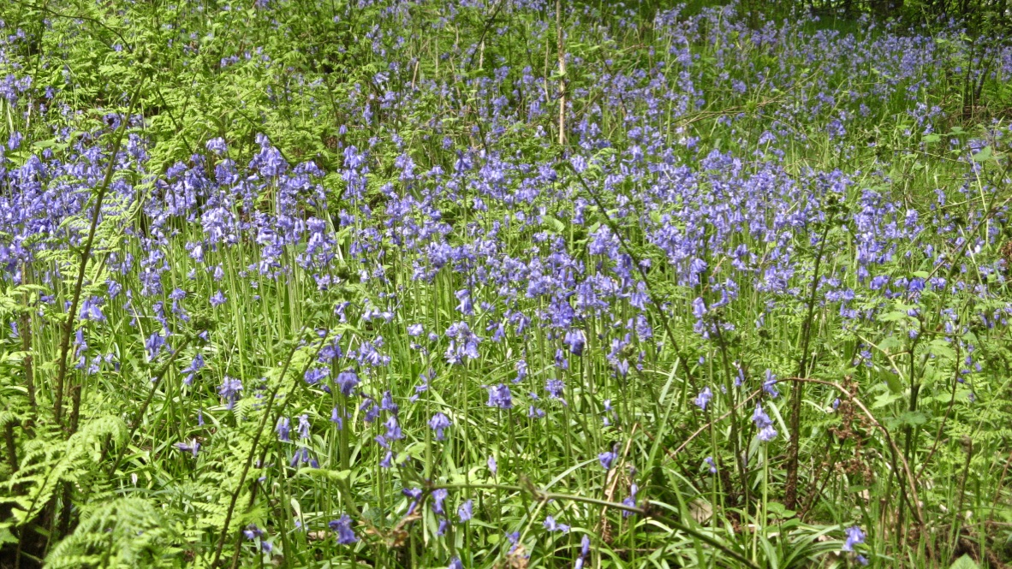
“The Great Peace towards which people of good will throughout the centuries have inclined their hearts, … is now at long last within the reach of the nations. For the first time in history it is possible for everyone to view the entire planet, with all its myriad diversified peoples, in one perspective. World peace is not only possible but inevitable. It is the next stage in the evolution of this planet....”
The Promise of World Peace

